Scaling-up Sustainable Land Management (SLM) practices by smallholder farmers:

working with agricultural extension services to identify, assess and disseminate SLM practices

in a nutshell

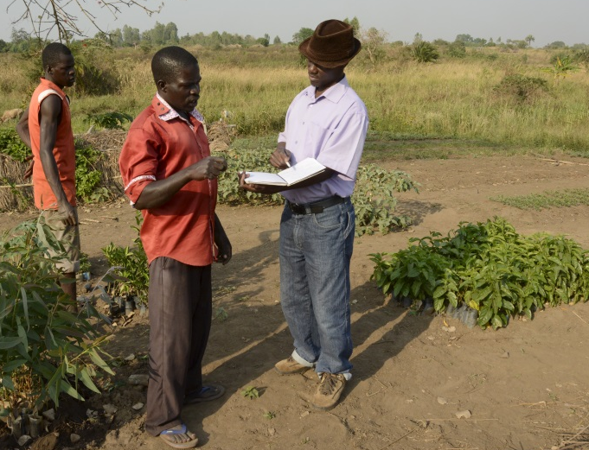
project aims
- Improve the resilience of smallholder farmers to climate change shocks
- Build capacities of agricultural extension services to identify and document climate-resilient SLM practices
- Build up a national SLM database
- Support smallholder farmers in adopting climate-resilient SLM practices
- Improve policy and incentive frameworks for scaling-up SLM

project partners

contact details
ULN: Mrs. Joy M.B. Tukahirwa
National Project Coordinator
E-mail: j.tukahirwa@infocom.co.ug
CDE/WOCAT Secretariat: Nicole Harari
Project coordinator
E-mail: nicole.harari@cde.unibe.ch
The project is implemented by the Centre for Development and Environment (CDE) of the University of Bern, Switzerland, hosting the World Overview of Conservation Approaches and Technologies (WOCAT) Secretariat, in collaboration with three national partners: the Uganda Landcare Network (ULN) in Uganda, the National Agriculture and Forestry Research Institute (NAFRI) in Lao PDR, and the Royal University of Agriculture in Cambodia. The project works in close collaboration with IFAD-supported loan investments in the three countries.

project duration
February 2016 – March 2019

funding
The project is supported and financed by the International Fund for Agriculture Development (IFAD).

background

Farmers are increasingly applying commercial agricultural practices. Through a greater use of agricultural inputs and the overexploitation of natural resources they are trying to maximize profits in the short term. This leads to an erosion of their natural resource base. The impact on their land and livelihood is severe and is further challenged by climate change. Establishing SLM practices is an alternative for smallholder farmers to meet market demands in a sustainable manner and build resilience to climate change.

Many innovative SLM practices exist, often developed by smallholder farmers themselves. However, only a few of these practices are documented in a standardized way. It is essential to evaluate existing and innovative SLM practices, identify their specific agro-ecologic conditions, their impacts and benefits, and understand how the practices react to a changing climate. This information helps to make decisions on which SLM practices to promote.

overall goal and expected outcomes

The overall goal of the project is to enhance the resilience of communities and their smallholder farmers to climate change shocks as well as pressures exerted by population growth, rapid urbanization, and economic expansion.

The project:
- Supports agriculture extension services to scale up SLM practices following a certain methodology. This methodology will be integrated into the IFAD-supported loan investment programme.
- Helps farmers in the districts of the IFAD programme to adopt SLM practices and improve their climate resilience.
- Establishes a national SLM policy dialogue forum and platform to improve policy and incentive frameworks for scaling up SLM.

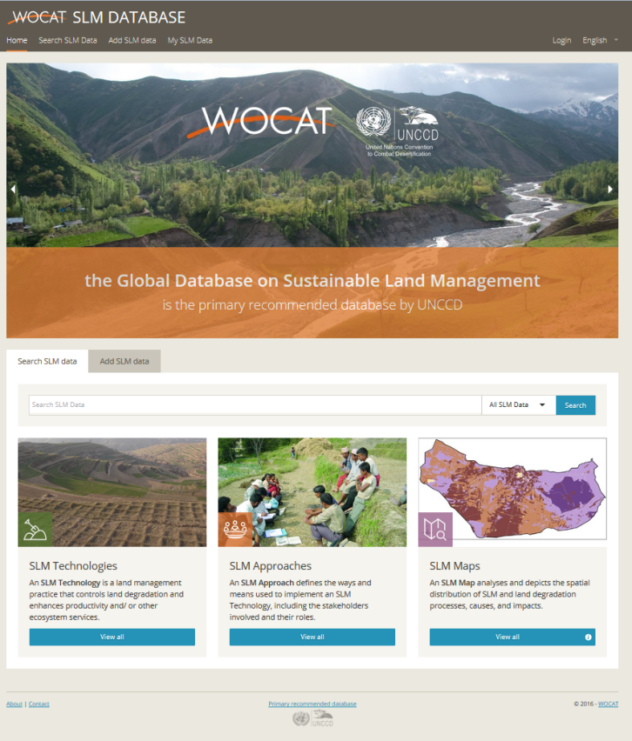
capacity building and tools
The project develops the capacities of agriculture extension staff to use the participatory WOCAT tools and methods for knowledge management and decision support in SLM. The tools include: the Questionnaires on SLM Technologies and Approaches and related Global Database on SLM (https://qcat.wocat.net/); the mapping tool to map land degradation and SLM; and the SLM decision support tool.

These tools and methods are widely used by many organizations worldwide. The Global Database on SLM is recognized by the United Nations Convention to Combat Desertification (UNCCD) and is used by UNCCD Member States to report their SLM Best Practices.

ULN will organize Trainings of Trainers (ToTs) to create a cadre of extension workers fully knowledgeable in using WOCAT tools and methods.

institutional setting
The CDE, hosting the WOCAT Secretariat, is responsible for the overall project coordination and implementation in the three countries. At national level, the project partner ULN is responsible for the coordination and implementation of project activities with agricultural extension services. ULN works closely with the IFAD-supported loan investment, the Programme for the Restoration of Livelihoods in the Northern Region (PRELNOR) to enhance country operations and to embed SLM tools and methodologies into existing local/national extension systems.

Within the framework of the SLM policy dialogue forum and platform the project collaborates with relevant national and international institutions active in the field of SLM.

Useful links
ULN: www.ugandalandcare.org
CDE: www.cde.unibe.ch
WOCAT: www.wocat.net
IFAD PRELNOR: http://operations.ifad.org/web/ifad/operations/country/project/tags/uganda/1681/project_overview

