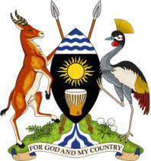 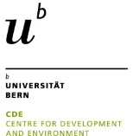 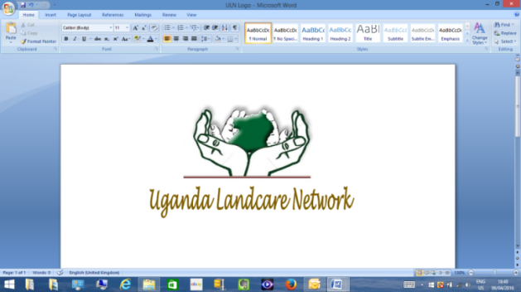 

**Funded by** 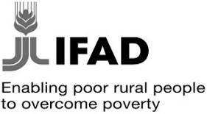

**Scaling - up Sustainable Land Management (SLM) practices by smallholder farmers: working with agricultural extension to identify, assess and disseminate SLM practices**

**(2016-2019)**

The World Overview of Conservation Approaches and Technologies (WOCAT) global network whose secretariat is hosted by the Centre for Development and Environment (CDE), University of Bern, Switzerland has an ongoing partnership with three national partners: (Royal University of Agriculture in Cambodia[1]; National Agriculture and Forestry Research Institute in Lao PDR[2] and Uganda Landcare Network in Uganda[3]). This partnership is towards implementation of a three -year IFAD funded project (2016-2019) entitled ‘Scaling-up Sustainable Land Management (SLM) practices by smallholder farmers: working with agricultural extension services to identify, assess and disseminate SLM practices’. The project’s overall goal is to enhance the resilience of communities and their smallholder farmers to climate change shocks as well as pressures exerted by population growth, rapid urbanization, and economic expansion. In Uganda, the project is designed to harness synergies while adding value to an the IFAD funded government investment programme entitled ‘Project for the Restoration of Livelihoods in the Northern Region (PRELNOR)’ [4] implemented by the Ministry of Local Government (MOLG) [5].

The Scaling-up SLM project is implemented in 9 districts, Lamwo, Adjumani, Amuru, Gulu, Nwoya, Agago, Kitgum, Pader plus a new district Omoro[6] curved from previous larger Gulu district and approved by government effective July 1 2016, 25 sub counties, and 28 catchments.

1. Royal University of Agriculture ( RUA) - Center for Agricultural and Environmental Studies (CAES) [www.rua.edu.kh](http://www.rua.edu.kh)
2. National Agriculture and Forestry Research Institute ( NAFRI) [www.nafri.org.la](http://www.nafri.org.la)
3. Uganda Landcare Network (ULN) [www.ugandalandcare.org](http://www.ugandalandcare.org)
4. <https://operations.ifad.org/web/ifad/operations/country/project/tags/uganda/1681/project_overview>
5. <https://www.molg.go.ug/sites/default/files/Ministerial-Policy-Statement-Local-Government-and-LGFC.pdf>
6. <http://www.parliament.go.ug/index.php/about-parliament/parliamentary-news/680-parliament-creates-23-new-districts>

   